Project Proposal for Term 2

What type of Photography are you interested in? (see sheet)
Street Photography

Who is your biggest influence (Who did you copy from the initial list?) and what interests you most about their work?
Fred Herzog is my biggest influence. I’m interested on how he take all the pictures that is extraordinary because you can capture it just once and he captures it beautifully. You can see a lot of variation on streets just be wise and patient.
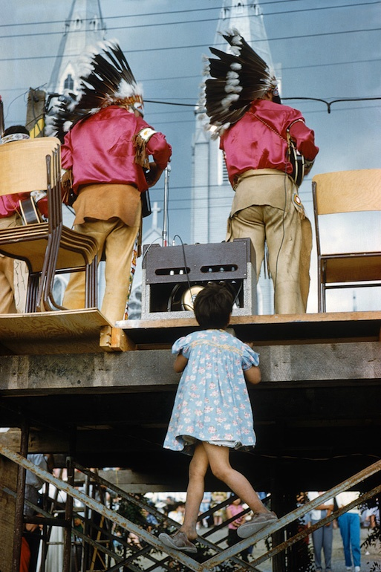

What are some themes that your influential photographer explores in their work? Why does this interest you?
Everything on our streets (buildings, busy street, people, cars, and many more) It interest me because it is too simple and it doesn’t need that much of effort but the timing, capture the best moments that is happening on the streets so be ready with your camera because the scene can only take like a minimum of 5 secs.

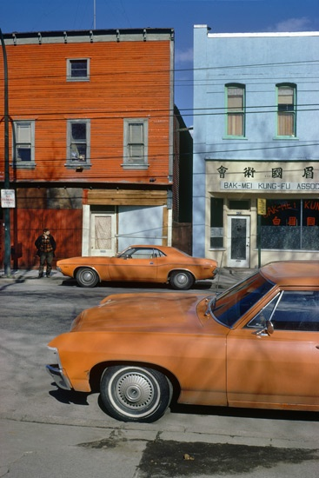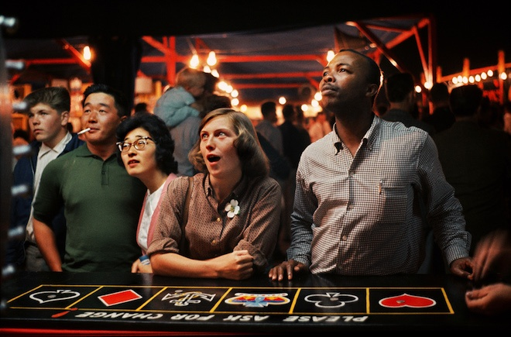

What question do you hope to answer in creating your photographs?
What did I do to capture that moment that is very fast to happen?
What kind of strategies did I use to capture those scenes on streets?

Proposal:
Tell me the scope and sequence of your project. What do you want to explore and how will you get the results you want? What do you need from me? How can I help facilitate your project?

December 7-21: Copy atleast 3 pictures of Fred Herzog and upload it to my website.
Winter Break: Look for a great shots in the streets this coming holidays.
Ms. Boulet can suggest places that I can go to capture great photos instead of my neighbourhood.

